I will do it python language, because the python is the best for making bot.

This is the sketch interface.

0%

Getting product list…

Start

Close

…

C:\Users\dev1121\Documents\Bot\users.csv

User List:

https://shopee.com.my/cadarstation

Shop URL:

I will implement a bot for the shopee.com with following logic and steps.

1. You have to input the shop URL.(ex: <https://shopee.com.my/cadarstation>)
2. Then, you must prepare the user list with .csv file and input the path of that file. This file will contain the user information with below example file.



1. You click “Start” button. Then the bot will process following actions for every user.
   1. Login and visit the shop URL, and then click follow button.

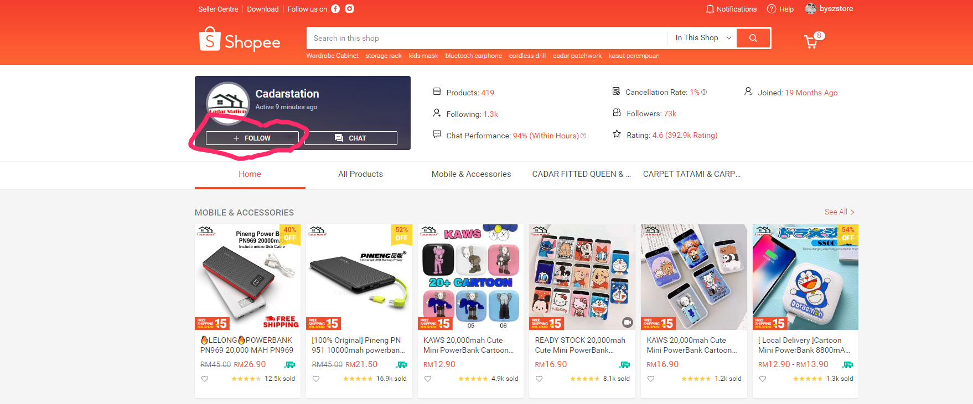

* 1. Scrap the URL list for all products of this shop and save the list to file.

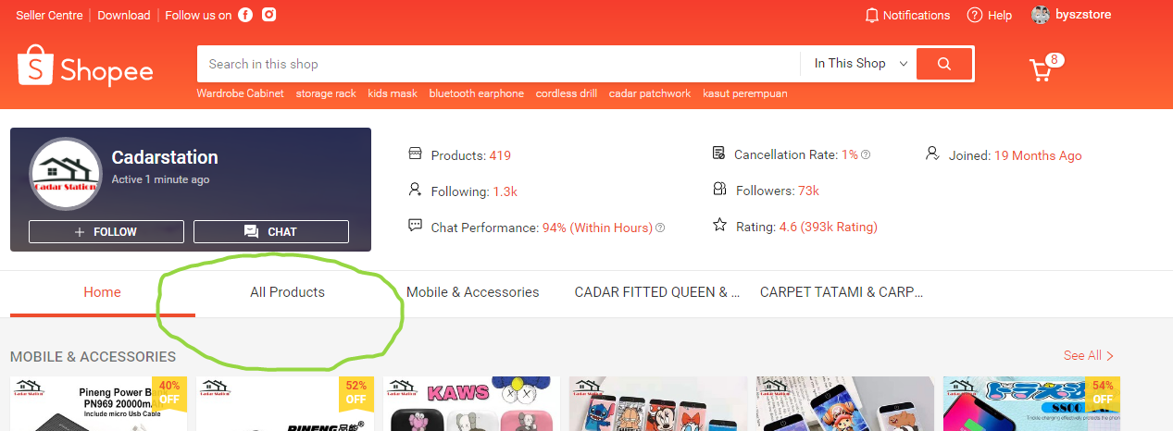

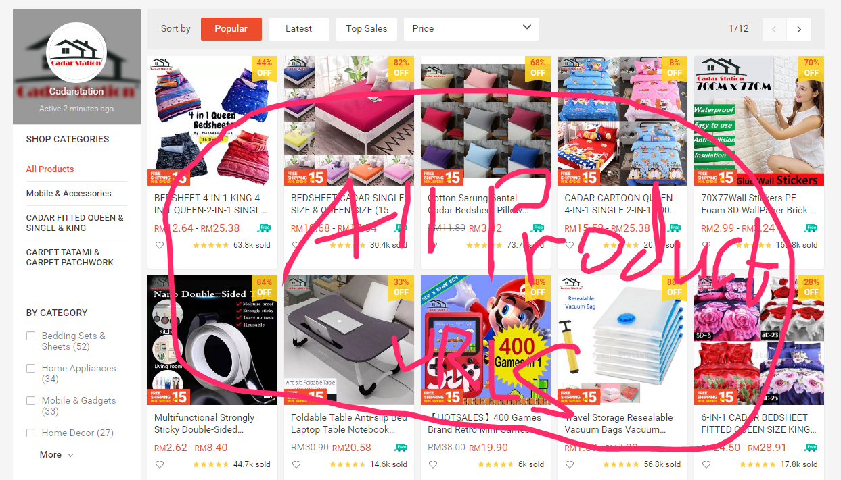

* 1. And then visit every product URL and increase the favorite number.

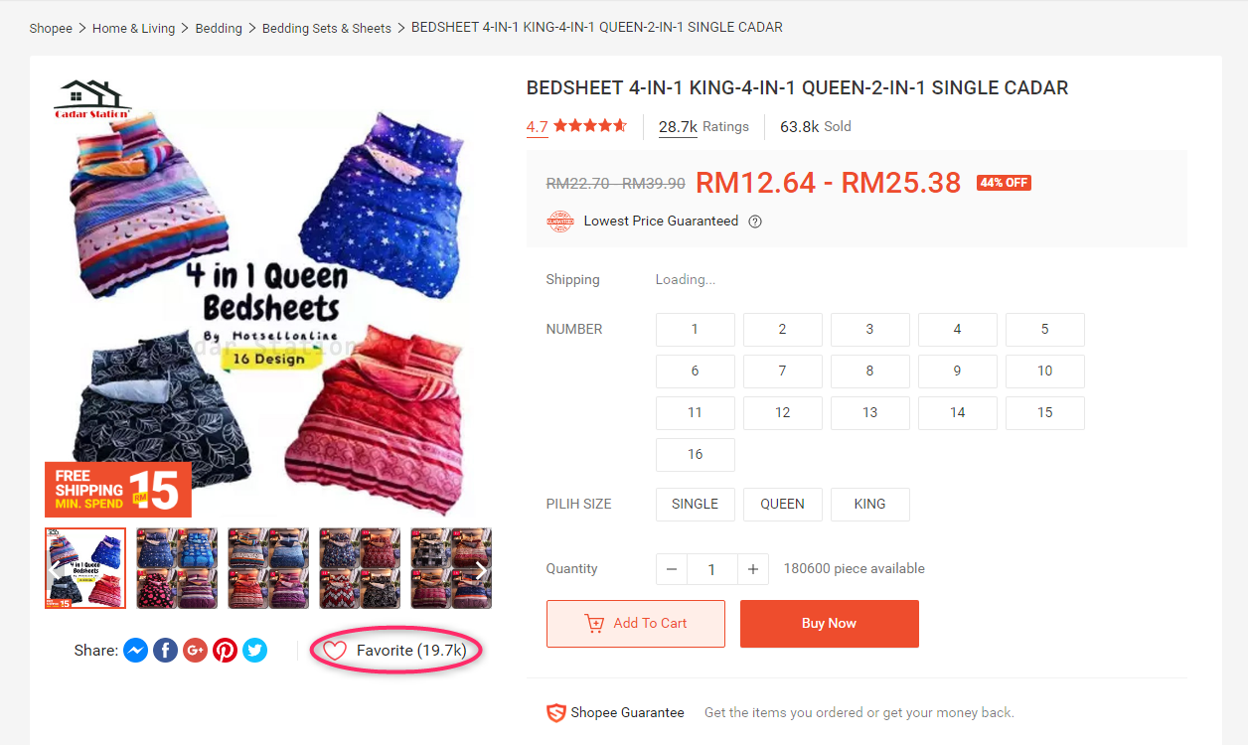

1. When you click “Close” button, the bot is exited.